**Program Structures & Algorithms**

**Spring 2022**

**Assignment No. 3**

Name: Yucong Liu

(NUID): 002192381

* **Task**

Step 1:  
(a) Implement height-weighted Quick Union with Path Compression. For this, you will flesh out the class UF_HWQUPC. All you have to do is to fill in the sections marked with // TO BE IMPLEMENTED ... // ...END IMPLEMENTATION.

(b) Check that the unit tests for this class all work. You must show "green" test results in your submission (screenshot is OK).

Step 2:  
Using your implementation of UF_HWQUPC, develop a UF ("union-find") client that takes an integer value n from the command line to determine the number of "sites." Then generates random pairs of integers between 0 and n-1, calling connected() to determine if they are connected and union() if not. Loop until all sites are connected then print the number of connections generated. Package your program as a static method count() that takes n as the argument and returns the number of connections; and a main() that takes n from the command line, calls count() and prints the returned value. If you prefer, you can create a main program that doesn't require any input and runs the experiment for a fixed set of n values. Show evidence of your run(s).

Step 3:  
Determine the relationship between the number of objects (n) and the number of pairs (m) generated to accomplish this (i.e. to reduce the number of components from n to 1). Justify your conclusion in terms of your observations and what you think might be going on.

* **Output screenshot**

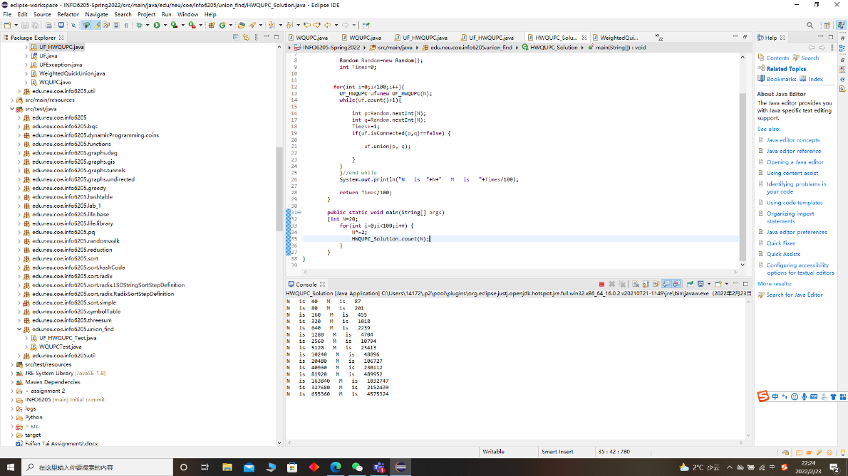

* **Relationship Conclusion**

**I think the relationship between N and M is close to linear relationship.**

M=a*N+b

In my test a is close to-8.42, and b is close to a 7.57

* **Evidence / Graph**

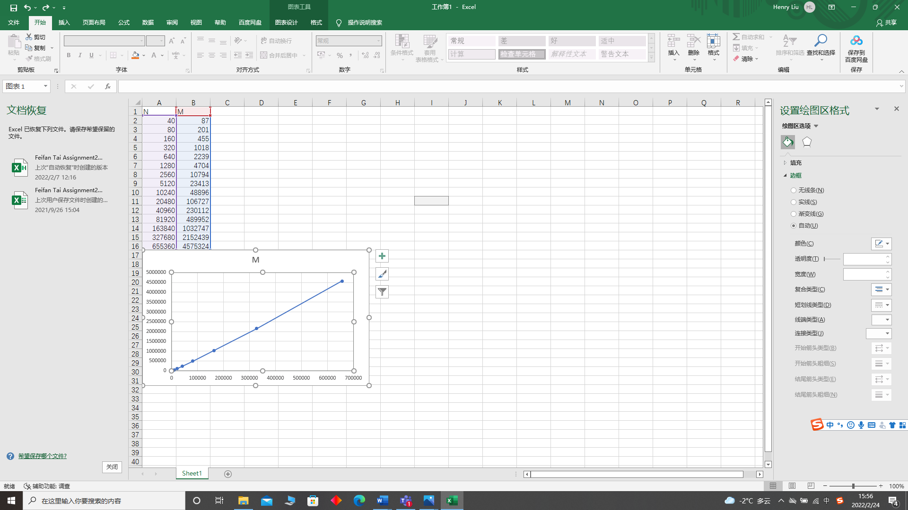

* **Unit tests result**

